Penny Mordaunt MP

Minister of State for Disabled People, Health and Work

Department for Work and Pensions

Caxton House   
Tothill Street  
London  
SW1H 9NA

1 December 2016

Dear Minister,

**UN CRPD Committee inquiry into the UK under article 6 of the CRPD Optional Protocol, and the UK Government’s response**

As the UK Independent Mechanism (UKIM) under the UN Convention on the Rights of Persons with Disabilities (CRPD), we are writing to you about the CRPD Committee’s inquiry into the UK. We welcome the publication of the inquiry report, and we are concerned by its conclusion that the UK Government’s programme of social security reform since 2010 has resulted in grave or systematic violations of disabled people’s human rights. Of even greater concern is the UK Government’s response, which suggests that it will not be taking action on any of the recommendations.

We ask that you reconsider this position in view of the continuing impact on disabled people’s lives, and note that similar concerns have been raised separately by the UN Committee on Economic, Social and Cultural Rights, and the UN Special Rapporteurs on Housing, Disabilities, Poverty and Food.

UKIM submitted detailed evidence on all aspects of the inquiry, acknowledging differences in provisions across the UK and devolved governments. The inquiry covered three disability rights: living independently and being included in the community; work and employment; and adequate standard of living and social protection. In view of the broad-ranging law and policy changes since 2010, we also submitted evidence concerning the impact on disabled people of changes to health and social care provision, and access to justice. In addition, we helped to facilitate the inquiry team’s visit to the UK in 2015, which included interviews with witnesses across governments, academia and civil society. Through our engagement we know that the process was robust and comprehensive, based on a rigorous review of the available evidence.

Ahead of the International Day of Persons with Disabilities on 3 December, UKIM calls on the UK Government to reaffirm its commitment to promoting and protecting the rights of disabled people, and urgently reconsider the inquiry’s recommendations. The upcoming examination of the UK before the CRPD Committee in 2017 is a timely opportunity for the UK Government to demonstrate how seriously it takes the inquiry’s conclusions by taking immediate steps to protect disabled people’s rights in advance of the examination.

We enclose a summary of our analysis in relation to each of these matters, and UKIM would be happy to meet with you to discuss them further.

Yours sincerely,

UK Independent Mechanism:

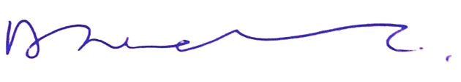

David Isaac, Chair

Equality and Human Rights Commission



Les Allamby, Chief Commissioner

Northern Ireland Human Rights Commission



Dr Michael Wardlow, Chief Commissioner

Equality Commission for Northern Ireland



Judith Robertson, Chair

Scottish Human Rights Commission