Applying behavioural insights to reduce pregnancy- and maternity- related discrimination and disadvantage

The Behavioural Insights Team

Tiina Likki and Chiara Varazzani

Acknowledgements
The authors would like to thank the Equality and Human Rights Commission project team (Rosie Wallbank and Sue Coe) for their guidance and helpful suggestions throughout the project. The views expressed in this report are the authors’ own.

Contents

List of tables and figures 4
List of abbreviations and acronyms 5
Executive summary 6
Background 9
Target 11
Target behaviour 1: Flexible recruitment 12
Target behaviour 2: Health and safety 14
Target behaviour 3: Recruitment 15
Explore 17
Risk aversion and ambiguity aversion 17
Unconscious gender bias in recruitment 19
Reduced cognitive capacity due to scarcity 21
Defaults 23
Social norms 23
Solution 25
Channel 1: Partnering with an online job board 26
Channel 2: Emailing employers 27
Channel 3: Partnering directly with an employer 29
Channel 4: Reaching mothers via midwife or GP 30
Trial 31
Partnering with an online job board 32
Emailing employers 41
References 48
Appendix 1: Long list of target behaviours 48
Contacts 53

List of tables and figures

Tables
Table 1. Scoring short-listed target behaviours from workshop
Table 2. Applicability of channels across three target behaviours

Table 3. Summary of trial proposals

List of Figures
Figure 1. Different approaches to flexible working among employers
Figure 2. Showing the number of applicants increased job applications among women
Figure 3. Male applicants are rated as more competent and hireable than female applicants
Figure 4. Women’s contributions are valued more highly when their gender is not revealed
Figure 5. Joint evaluation of applications reduces gender bias
Figure 6. Farmers make more cognitive errors when under scarcity
Figure 7. Illustration of design for trial 1A
Figure 8. Example of template for the control group in trial 1A
Figure 9. Example of template for the treatment group in trial 1A
Figure 10. Example of testing whether flexibility of information encourages women to apply for jobs in trial 1B
Figure 11. Illustration of design for trial 1B
Figure 12. Example of control and treatment group adverts in trial 1B
Figure 13. Illustration of design for email trials

List of abbreviations and acronyms
Acas  BEIS  BI  BIS | Advisory, Conciliation and Arbitration Service  Department for Business, Energy and Industrial Strategy  Behavioural insights  Department for Business Innovation and Skills
BIT | Behavioural Insights Team
CIPD  CV | Chartered Institute of Personnel and Development  Curriculum vitae
EHRC  GP  HMRC  HR  HSE  KIT  NHS  MAT B1  RCT | Equality and Human Rights Commission  General practitioner  Her Majesty’s Revenue and Customs  Human resources  Health and Safety Executive  Keeping in touch  National Health Service  Maternity certificate  Randomised controlled trial
SMEs | Small and medium-sized enterprises
TEST | Target; Explore; Solution; Trial
UK | United Kingdom

Executive summary
Pregnancy- and maternity-related discrimination and disadvantage remain key issues holding back women in the labour market. Research conducted by the Equality and Human Rights Commission (‘the Commission’) and Department for Business, Energy and Industrial Strategy (BEIS) revealed the scale of these issues, with three quarters of working mothers reporting negative and potentially discriminatory experiences. This report looks at how evidence from behavioural science can offer new and innovative ways to change the behaviour of both employers and women. The report presents research conducted in early 2016 by the Behavioural Insights Team (BIT) for the Commission.
The report is structured into four main sections following BIT’s four-step ‘TEST’ methodology: Target; Explore; Solution; Trial. First, the ‘Target’ section describes the three challenges selected by the Commission based on earlier research findings:
Flexible working: encouraging employers to create and advertise flexible posts. The aim is for employers to see flexible working as a normal way of working and proactively consider flexibility rather than reacting to requests, to ensure that working flexibly does not lead to negative outcomes for the employee.
Health and safety: encouraging employers to proactively discuss pregnancy- and maternity-related health and safety and to tackle any risks that are identified, as well as have follow-up conversations if necessary as the pregnancy progresses.
Recruitment: encouraging employers to conduct recruitment in a way that does not discriminate against pregnant women, new mothers or women of childbearing age. In particular, the aim is to encourage employers to adopt recruitment practices that reduce unconscious gender bias.
The ‘Explore’ section presents five central behavioural biases or tendencies that are likely to influence choices that employers and mothers make. Behavioural biases are well-documented patterns in human behaviour that help explain why people sometimes make poor or irrational decisions and why what people think or say may not always correspond with what they do.
The ‘Solution’ section provides an overview of four light-touch ways to influence behaviour among employers and female employees and how these might be used to tackle the three key areas of flexible working, health and safety, and recruitment. The four channels are:
- Partnering with an online job board
- Emailing employers
- Partnering directly with an employer
- Reaching mothers via midwife or GP
The ‘Trial’ section presents five potential ideas for testing how the proposed channels can be used to shift behaviour in the three key areas. The first set of trials is based on partnering with an online job board to influence behaviour. In the first trial, we would test whether changes to the job advert template increase the number of employers who offer flexible working. In the second trial, we would test whether giving applicants more information about whether a job can be done flexibly or not increases application rates, especially among women.
The second set of trials test what messages are most effective in changing employer behaviour. These trials use emails as the channel for delivering messages to employers. The three trials each target one of the three challenges: flexible working, health and safety, and recruitment. Some employers would receive messages that draw on behavioural science principles encouraging them to take action, while some would receive more typical messages that organisations use when communicating with employers. By tracking how these different groups of employers act after receiving the messages, we would be able to evaluate the effect of each type of email.
The five trial ideas presented in this report describe what possible behavioural interventions might look like and how their effect could be evaluated. These propositions are indicative and the final details of each trial would depend on the trial partner, availability of data, and the number of employers who take part in the trials. If the Commission decides to put these ideas into practice and test their effects, we would work with the trial partners to establish more detailed trial and evaluation plans.
Once completed, the trials would add to the evidence base by producing concrete figures on the percentage of employers and women who changed their behaviour as a consequence of the interventions. This information could be used by employers, representative organisations and the Government to move towards a position where fewer women face discrimination and disadvantage in the labour market.

Background
In early 2016, the Equality and Human Rights Commission (‘the Commission’) asked the Behavioural Insights Team (BIT) to develop interventions that help reduce pregnancy- and maternity-related discrimination and disadvantage in the workplace. In 2015, the Commission made a substantial contribution to the evidence base by surveying a large number of employers and women. BIT has spent three months learning from this evidence and investigating relevant findings from behavioural science to develop proposals. This report is a summary of those proposals and a detailed outline of the methodology that underlies them.
‘Behavioural insights’ (BI) draws on research from behavioural economics, psychology, and neuroscience to understand how humans behave and make decisions in everyday life. By better understanding how people respond to different contexts and incentives, and the practical and structural barriers they face, decision-makers can design and implement better policies and services.
Typically, behavioural insights interventions focus on the environment and social context in which we make decisions. They are often small and inexpensive levers that can result in disproportionate changes in behaviour. A classic example is that late payers of tax are much more likely to pay their taxes if they are told: ‘Nine out of ten people pay their taxes on time’. Depending on the target behaviour, behavioural insights interventions can be used on their own or in conjunction with other policy levers.
BIT has developed a four-stage project methodology which we use for our projects. The four stages are:
- Target – in the target stage, we work with clients to identify the behaviours that show the most promise for a BIT trial.
- Explore – in the explore stage, we use a variety of methods to understand the context in which behaviours take place; in this case, the explore phase was supported substantially by the Commission’s survey work.
- Solution – this stage requires an investigation of the empirical behavioural science literature; the use of creativity; and co-design with end users (in this case, mothers).
Trial – the trial stage involves a pragmatic adoption of evaluation methodologies (most often randomised controlled trials, or RCTs) to test the effect on the solutions.
This report considers the first three stages of TEST and finishes with two sets of trial proposals. These trial proposals can be further developed and implemented as a separate project following this report.

Target
Pregnancy and maternity discrimination and disadvantage includes a wide array of behaviours (BIS and EHRC, 2015). For a behavioural insights project, we need concrete target behaviours. To achieve this, we ran a workshop to produce a long list of possible target behaviours (see Appendix 1). The Commission reduced this list to a smaller number of possible target behaviours which we scored from 1 to 5 based on their impact and feasibility (where 1 equals very low, and 5 equals very high).
We then discounted anything that scored under 3 and gave more weight to impact over feasibility when choosing which issues to focus on.

Table 1. Scoring short-listed target behaviours from workshop
Target behaviour | Impact | Feasibility
Women raise issues or complaints more often | 2 | 2
Employers encourage women to raise issues | 3 | 2
Employers proactively discuss health and safety and tackle any risks that are identified, as well as have follow-up conversations if necessary | 4 | 4
Employers maintain contact more during maternity leave | 2 | 5
Employers encourage flexible working | 3 | 3
Employers conduct recruitment in a way that does not discriminate against pregnant women, new mothers or women of childbearing age | 4 | 5
Employers advertise job roles that promote flexible working | 3 | 3

Based on the ranking exercise, the following three behaviours were selected as target behaviours for the project:
1. Flexible recruitment: encouraging employers to actively create and advertise posts with flexible working options. The aim is for employers to proactively consider flexibility in designing and advertising jobs rather than reacting to requests, to ensure that working flexibly does not lead to negative outcomes for the employee.
2. Health and safety: encouraging employers to proactively discuss pregnancy- and maternity-related health and safety and to tackle any risks that are identified, as well as to have follow-up conversations if necessary as the pregnancy progresses.
3. Recruitment: encouraging employers to conduct recruitment in a way that does not discriminate against pregnant women, new mothers or women of childbearing age. In particular, the aim is to encourage employers to adopt recruitment practices that reduce unconscious gender bias.

Target behaviour 1: Flexible recruitment
Jobs are flexible if they give employees some control of working time (for example, using part-time, staggered hours, compressed hours or flexitime); working location (for example, working from home); or the pattern of working (for example, job sharing). The specific type of flexibility that best supports the employee will differ from case to case. The aim is to get more employers to actively advertise posts with flexible working options and to offer flexible working in a genuine and transparent way which, in the long run, will help normalise flexible working and therefore help working mothers.
At the time of this study, there seems to be a mismatch between the number of employees who would like to work flexibly and employers’ readiness to offer flexible arrangements. Based on a 2014 poll, an additional 8.7 million UK-based full-time workers want to work flexibly (whether part-time or more remotely) (Timewise, 2014). However, an analysis of over 5 million job adverts on UK job boards in 2015 showed that, of all full-time jobs paying £20,000 or more, only 8.7% were advertised with flexible working options (Timewise, 2016). At the same time, a survey of part-time workers showed that 52% felt nervous to ask for flexibility when applying for or accepting a new job and 42% feared it would damage their chances of getting the job (Timewise, 2013). These issues are intensified by the fact that some managers believe that flexible workers are less ambitious than full-time workers.
In research by the Commission, the vast majority of employers (96%) reported that they offered at least one flexible working practice (EHRC, 2016a). However, mothers commonly reported there being ‘a price to pay’ for having flexible working requests approved, with around half of mothers (51%) who had their flexible working request approved saying they experienced unfavourable treatment as a result. This included issues such as being given fewer opportunities than other colleagues at the same level, receiving negative comments from their employer or colleagues, or feeling that their opinion was less valued (EHRC, 2016b).
Not all employers have a similar view of flexible working options, which means that they are likely to require somewhat different interventions. We have constructed a simple continuum of employers to help illustrate this point, ranging from those whose behaviour is easiest to change (top) to those whose behaviour is the most difficult to change (bottom).

Figure 1. Different approaches to flexible working among employers
Publicly Flexible | Offer flexible working and mention this in their job adverts.
Privately Flexible | Offer jobs that can be done flexibly but who do not mention this in their job adverts, therefore potentially putting off some candidates.
Unaware | Do not offer flexible working because they have not given it much thought.
Unconvinced | Have considered flexible working but do not offer it because they are not convinced it is a good idea.
Inappropriate | Do not offer flexible working either because it is not possible due to the nature of the work or because they would never consider it.

Target behaviour 2: Health and safety
The aim is to encourage employers to proactively discuss pregnancy- and maternity-related health and safety and to tackle any risks that are identified, as well as have follow-up conversations if necessary as the pregnancy progresses. This ensures that pregnant women have the knowledge and confidence required to continue to do their job and feel supported (EHRC, 2016b).
It is a legal obligation for employers to regularly review general workplace risks. However, employers do not have to conduct a separate risk assessment for an employee who is an expectant or new mother. Evidence gathered by the Commission indicates that there is great variation in how employers communicate about health and safety and whether they take the necessary measures to tackle issues (EHRC, 2016a).
According to research commissioned by the Commission, 37.5% of women said their employer did not initiate a discussion about potential risks after they told the employer that they were pregnant, and 19% of women said they identified risks that their employer did not. Overall, 48% of the women surveyed said either their employer did not initiate a discussion about risks or that not all the risks identified were tackled. Of mothers surveyed, 4% reported leaving their job because risks were not properly tackled; if scaled up to the general population, this could mean as many as 21,000 mothers per year leaving jobs because risks are not tackled (EHRC, 2016b).
The Commission’s research also showed that, in some instances, mothers felt that their employer had a ‘tick-box’ approach to assessment and management of risk during pregnancy to comply with company procedures and that those conducting the risk assessments were not really interested in their welfare (EHRC, 2016b).

Target behaviour 3: Recruitment
We want employers to recruit in a way that does not discriminate against pregnant women, new mothers or women of childbearing age. There are a number of stages in a recruitment process, from posting a job advert to interviews and salary negotiations. The third target area concerns all of the behaviours associated with these stages. We have deliberately left this open to give us room to determine which behaviours are feasible once we know more about what kind of trial we might wish to run.
Prejudice against pregnant women and mothers can take the form of both explicit and implicit (or unconscious) attitudes, which can in turn lead to discriminatory behaviours. In research conducted by the Commission, 70% of employers openly said they thought that women should declare at recruitment stage if they were pregnant; 25% of employers thought it was reasonable to ask a woman of childbearing age about plans to have a family. These views illustrate the discriminatory practices that prejudiced views can lead to – even when many of the employers responding to the survey would probably not view themselves as explicitly having negative attitudes towards women.
As public attitudes have become more positive towards groups such as ethnic minorities and women, behavioural science has focused on overcoming implicit biases that can be automatic and lead to unintentional discrimination. Unconscious bias can also be built accidentally into practices and procedures. These designs lead to bad outcomes regardless of good intentions (Bohnet, 2016).
Recruitment practices that reduce unconscious bias include:
- Anonymising CVs so that certain information (for example, name) is hidden from the reviewers (Behaghel et al., 2011)
- Assessing CVs in groups rather than individually (Bohnet et al., 2012)
- Conducting structured interviews – asking all candidates the same set of predefined questions (Bragger et al., 2002)
- Involving people who did not interview the candidates in hiring decisions, as they will be less influenced by particular aspects of the selection process than those who interviewed candidates and better placed to take a balanced overview (Bock, 2015).

Explore
In the explore phase, we investigate the context in which our target behaviours are performed. The Commission has run a number of surveys on the prevalence of pregnancy and maternity discrimination and disadvantage (EHRC, 2016a; 2016b). To build on this work, BIT reviewed behavioural studies on gender bias and discrimination and conducted eleven semi-structured interviews with six employers and five mothers identified through personal networks and snowballing, with participants helping identify other interviewees. Due to the small number of interviews and the fact that they were sampled from our existing networks, the views and experiences expressed in the interviews are not representative of employers and mothers in general. We have primarily used the interview data to illustrate patterns that emerge from the findings in the Commission’s reports from quantitative surveys with employers and mothers.
In this section, we outline some key behavioural biases that we think have an influence on pregnancy and maternity discrimination and disadvantage in the workplace. Behavioural biases are well-documented tendencies in human behaviour that help explain why people sometimes make poor or irrational decisions and why what people think or say may not always correspond with what they do.

Risk aversion and ambiguity aversion
Risk aversion refers to the tendency to prefer certainty over risk, especially when the stakes are high. In other words, people tend to choose a certain or guaranteed gain over a gamble for an uncertain pay-out. Risk preferences change depending on whether the risk relates to a potential loss or a gain (Kahneman and Tversky, 1979). For instance, people tend to be disproportionately risk averse for losses with low probability. Loss aversion is a behavioural bias which can make a loss feel twice as powerful as a gain (Kahneman and Tversky, 1979). Risk aversion – intensified by loss aversion – may explain unwillingness among some employers to hire women of childbearing age, as pregnancy and maternity may be seen as risks from the employers’ perspective.
In the interviews we conducted, several employers clearly demonstrated risk aversion. For example, one line manager said, ‘There is always a fear among line managers that you haven’t done the things properly with pregnant women. We are always concerned about our legal responsibility. Ideally, I would like to have any exchange on this recorded.’
Ambiguity aversion, in turn, refers to a preference for known risks over unknown risks (Fox and Tversky, 1995). In other words, people dislike making decisions when they do not have information about the probability of different outcomes.
Emerging evidence suggests that men and women differ in ways that can account for some of the differences in labour market outcomes. For example, women are on average more averse to risk and ambiguity than men (Borghans et al., 2009). This implies that additional information about a job vacancy will encourage more women to apply.

A recent trial showed that women are more likely to apply for a job if told how many other people have already done so. For men, the extra information made no significant difference (see figure below) (Gee, 2015).

Figure 2. Showing the number of applicants increased job applications among women

Our interviews with mothers confirmed that they would find more information useful. For example, one mother said, ‘Knowing in advance that employers are open to flexible working would be a huge advantage for parents.’ Another said, ‘Knowing in advance that you can work flexibly when you have a child would potentially help fighting this kind of discrimination.’

Unconscious gender bias in recruitment

Unconscious bias has been shown to influence how others judge women’s performance. Corinne Moss-Racusin and her collaborators ran an experiment on academic hiring. They asked a number of science academics to rate the application materials of a student for a laboratory manager position. Some of the academics were given the CV with a male name and some with a female name. The rest of the CV was identical. On average, the academics rated the male applicant as more competent and hireable than the (identical) female applicant as well as suggesting a higher starting salary (Moss-Racusin et al., 2012).

Figure 3. Male applicants are rated as more competent and hireable than female applicants

Another study, conducted in an open source software community, found that women's contributions tend to be accepted more often than men's when gender information was hidden. However, when gender was revealed, women’s contributions were rejected more often than men’s (Terrell et al., 2016).

Figure 4. Women’s contributions are valued more highly when their gender is not revealed

Finally, research by Iris Bohnet has shown that people are more likely to favour men when they are asked to look through a batch of candidate profiles one by one and decide whether to hire each person (known as separate evaluation). When they are asked to choose from the same batch by comparing candidates with each other (known as joint evaluation) the gender bias disappears and they choose mainly based on performance (Bohnet et al., 2012).
As the figure below demonstrates, in the separate evaluation of a male-stereotypical task (a maths task), employers chose men over equally qualified women and even preferred lower performing men to more qualified women: 65% of the employers selected the lower-performing male employee, compared with only 44% who chose the higher-performing female employee.
In contrast, the joint evaluation eliminated the gender bias. In joint evaluation, employers were as likely to pick high performing women as men (57% to 52%). In sum, employers were more likely to select employees based on their performance in the joint evaluation compared with the separate evaluation.

Figure 5. Joint evaluation of applications reduces gender bias (maths task example)
Maths task

Reduced cognitive capacity due to scarcity
Scarcity refers to the feeling of not having enough (for example, time or money) and has been shown to influence cognitive capacity, which refers to the ability of the brain to process information and make decisions (Mullainathan and Shafir, 2013). In India, sugarcane farmers receive the vast majority of their earnings at harvest time. Researchers found that they had lower IQ scores before the harvest than after. This difference could not be explained by a difference in nutrition or physical exhaustion. The difference was nearly as big as if someone is given an IQ test after they have lost an entire night of sleep.

Figure 6. Farmers make more cognitive errors when under scarcity
In the case of employers, and perhaps particularly small and medium-sized enterprises (SMEs), the effects of scarcity are likely to influence decision-making at times such as the end of the financial year, when tax payments are due and expenses are high, or when the employer is otherwise busy and under time pressure. At times like these, employers are unlikely to dedicate energy to revising their recruitment practices or improving their health and safety policies.
Evidence on scarcity can help us design better interventions to influence employer behaviour. First, they show us that interventions aimed at changing employer behaviour should be timed to occur when scarcity is lowest. Second, if we assume that many small business owners as well as busy managers are often under constant scarcity, we should design and trial interventions that aim to make the decision-making environment as simple as possible for the employer; for example, by using defaults.

Defaults
Defaults refer to the options that are pre-selected if a person does not make an active choice. An example of defaults is to automatically enrol individuals into pension schemes. This makes them more likely to end up with a pension plan than if they have to actively opt in(Gov.uk, 2013). More subtle defaults include pre-ticked boxes on forms or the size of plates in a restaurant (people tend to eat less when they are given smaller plates).
Defaults exert influence because people regularly accept whatever the default setting is, even if it has significant consequences. In the context of employer behaviour, the power of defaults could be harnessed, for example, to design job advert templates where flexible working is chosen by default.

Social norms
People are influenced by what others around them do. Compliance with norms can stem from wanting to gain social acceptance, identifying with a group that shares those norms, or simply seeking to make accurate and valid decisions. A powerful example of how social norms can influence a group that is perpetually time poor comes from a trial conducted by BIT to reduce unnecessary antibiotic prescription among GPs. In the trial, 800 GP practices whose prescribing rate for antibiotics was in the top 20% for their National Health Service (NHS) Local Area Team were sent a letter from the Chief Medical Officer stating that ‘the great majority (80%) of practices in [the recipient’s local area] prescribe fewer antibiotics per head than yours’. Over six months, those who received the letter reduced their antibiotic prescribing rates by 3.3% compared with those who did not (Hallsworth et al., 2016).
Similarly, employers are likely to continue existing practices regarding flexible working or recruitment if they feel that they are in line with the majority of other employers.
Overall, existing research suggests several behavioural tendencies that are likely to disadvantage mothers. We found some support for these in the interviews we conducted, although the sample was too small to draw any conclusions based on the interviews alone. Based on the academic evidence and survey research conducted by the Commission, we note that:
- Employers’ behaviour may be influenced by risk aversion and some may overestimate the risk of litigation against them by mothers and pregnant women.
- Women often feel stressed about asking for flexible working when they do not know if they are taking a big risk by doing so.
- There are a number of practices that accidentally encourage discrimination against women in recruitment.
- Many employers are busy and this feeling of being time poor may affect their judgement and willingness to change.
- Employers are influenced by what others do.
In the next section, we will explore how this evidence can help us to change the behaviour of employers.

Solution
In this section, we set out proposed solutions to the three issues identified in the section on target behaviours (flexible recruitment, health and safety, and recruitment). We began by exploring which channels would be most appropriate for reaching a large number of employers and women and would enable us to test our interventions. We identified different channels by mapping what services women engage with during their pregnancy and what services or government touch-points employers interact with in relation to pregnant employees as well as more generally.
Based on this, we proposed four key channels that can be used to deliver interventions to tackle these issues:
1. Partnering with an online job board
2. Emailing employers
3. Partnering directly with an employer
4. Reaching mothers via midwife or GP
The table below shows which channels are most appropriate for each of the three issues.

Table 2. Applicability of channels across three target behaviours
 | Flexible working | Health and safety | Recruitment
1. Partner with an online job board | x |  | x
2. Email employers | x | x | x
3. Partner directly with an employer | x | x | x
4. Reach mothers via midwife or GP |  | x

We also considered other channels such as antenatal classes, nurseries, and pregnancy apps. These were consequently ruled out either because we felt that they did not have sufficient reach and scalability or because it would have been difficult to measure the effect of any interventions that used these channels. For instance, antenatal classes provide an excellent way of reaching pregnant women but do not allow measuring whether the intervention has an effect on the behaviour of our primary group (employers).

Channel 1: Partnering with an online job board
Employers often use third-party websites such as LinkedIn, Indeed, Monster or Universal Jobmatch to advertise their vacancies. Laura Gee worked with LinkedIn to run her study on social information and job applications (referred to in ‘Explore’). In her study, Gee reached thousands of people at a low cost and was able to test the effectiveness of the intervention. This study (and the others referred to in ‘Explore’) demonstrates that additional information on job adverts is likely to increase the number of female applicants. The mothers we interviewed also said they would be more likely to apply if adverts included information about flexible working.
If we partnered with an online job board, we could influence employer behaviour in the following ways:
- Prompting employers to mention flexible working conditions. Most online job boards require employers to fill in a web form to create their job advert. These forms typically do not prompt people to include information about flexible working. Simply asking employers to mention flexible working could make a substantial difference. For example, our work on charitable giving showed that simply asking people to leave money to charities while writing a will (as opposed to waiting to see if they mentioned it) doubled donation rates (BIT, 2013).
Behavioural messages based on loss aversion. Loss aversion is the tendency to experience losses as larger than corresponding gains, which leads to losses having a greater effect on preference (Kahneman et al., 1991). Messages based on loss aversion could encourage either flexible recruitment or unbiased recruitment practices. Below are some examples of behavioural messages based on loss aversion.
Example behavioural messages based on loss aversion
Loss of potential candidates. Use statistics on how many people would like to work flexibly and say that if the employers do not mention flexible hours in the job adverts, they are losing potential excellent candidates who are looking for jobs with flexible hours.
Loss of talent. Get employers to think about how good their current talent pool is and how flexible working can help retain it.
Loss of productivity. Highlight that flexible workers are more productive than their counterparts.

Channel 2: Emailing employers
The second possible channel is to influence employers by emailing them. This approach is simple and could be used to encourage all three target behaviours. Depending on the number of employers, they could be divided into two or more groups, each of which would receive a different message. This approach allows testing what kind of behaviourally informed messaging is most effective in getting employers to move towards the target behaviour.
To reach employers, the Commission could either use an existing mailing list (for example, the one used to conduct the Commission’s surveys, or an HMRC mailing list), or compile a new mailing list using web scraping (the ‘Trial’ section gives more information on what mailing lists to use and how to measure the effect of the different emails on employer behaviour). Evidence from behavioural science points to the importance of using an authoritative or attractive messenger to make the message effective (Dolan et al., 2010). It is therefore important to ensure that email is sent by an organisation that is likely to attract the employer’s attention.
It is also important to consider who within the organisation should receive the email. Practical constraints may cause difficulties, but where possible we could target messaging about flexible working or recruitment to key decision makers (for example, the director of an SME or the human resources (HR) person in charge of hiring), and line managers when messaging about the management of health and safety through conversations.
Behavioural messages: Behavioural science has many different techniques to ‘nudge’ people towards a desired behaviour. The most effective technique for a situation depends on the context and the target group, so testing several messages against each other is the best approach to identify which one should be used more widely. In addition to loss aversion (see above), many other messages are likely to be effective.

Possible messages to encourage flexible recruitment
Peer example. Give employers and managers concrete examples of how other managers have managed to make jobs flexible – how they overcame any challenges and the benefits this brought.
Reciprocity. Highlight how employers themselves have benefited and continue to benefit from the care activities done by women, and ask them what they can do in return; for example, offering flexible working arrangements. Reciprocity refers to the tendency that people have to want to repay a favour or a gift.
Community values. Encourage employers to reflect on how an employee they know would benefit from more employers offering the possibility to work flexibly.

Possible messages to encourage conversations about health and safety
Loss aversion. Make employers feel that, by not addressing health and safety, they risk losing a good employee or that it would be more likely that the pregnant woman or new mother needs to take time off work (either because of health concerns or because of lower commitment to the job).
Reciprocity. Increase loyalty of employers to pregnant employees by getting them to think of ways in which the employee who is now pregnant proved indispensable in the past year.

Possible messages to encourage good recruitment practices
Social norms. Tell employers how many other companies use non-discriminatory practices in employment and highlight the quality of the applicants they get. Telling people what the majority of others do (that is, the social norm) is an effective way to influence behaviour.
Counter-stereotypical information. Provide hiring managers with information about parents that goes against existing stereotypes (for example, that being a parent does not entail a lack of commitment to a job) (Morgan et al., 2013).
Language in adverts: Tell managers about the effects that ‘masculine’ versus ‘feminine’ words in a job description have – that is, they affect the gender makeup of the pool of applicants. Stress that this language affects the quality of the applicant pool (Gaucher et al., 2011).

Channel 3: Partnering directly with an employer
The third possible channel is to partner directly with an employer to test how different organisational practices can help influence behaviour among managers and employees. This channel can be used to test many different approaches to all three target behaviours, so we only give a few examples below.
Influencing managers
Idea 1: Advice on interactions. Giving managers guidance on how to bring up health and safety with a pregnant employee. The aim is to reduce possible risk aversion among managers who may fear that they open themselves up to legal challenges if they get something wrong.
Idea 2: Behavioural messages. Similar to the approach outlined in the section on emailing employers, we could use different messages to managers to see which ones lead them to provide more flexible working possibilities to their staff. If the partnership is with a large organisation, it could be more appropriate to target the interventions at HR staff.
Influencing employees
Idea 1: Behavioural messages. Similar to approach outlined in the section on emailing employers, we suggest testing different messages to employees. Particularly interesting here would be to encourage men to take parental leave; in the long term, this could lead to less discrimination against women in recruitment.

Channel 4: Reaching mothers via midwife or GP
The fourth proposed channel is to use midwives or GPs as a messenger to influence the behaviour of pregnant mothers (with the ultimate aim of influencing employer behaviour and decision making). All women see a midwife at an early stage in their pregnancy. Midwives could therefore be used to provide support relating to conversations about health and safety as well as flexible working.
Idea 1: Ask midwives to bring up certain topics with mothers. Midwives could be advised to prompt women to talk about health and safety concerns with their employer. Alternatively, midwives could provide women with advice about how to bring up flexible working with their employer.
Idea 2: Create a new document or form. The Commission could develop a standard form for pregnancy-related health and safety risks that midwives and GPs could use to flag specific concerns and to suggest adaptations. In addition, midwives and GPs could be provided with a list of simple changes commonly needed (possibly by industry or sector, and with case studies of measures taken by other employers). The midwife would fill in the form and give it to the mother who would take it to their employer to take action (for example, when providing written evidence of pregnancy).
This approach is particularly likely to work for small businesses that might not have a HR professional whose role is to discuss health and safety risks. It also uses the ‘messenger effect’: the form is filled by a midwife who is a medical authority and therefore likely to be an influential source of information (Dolan et al., 2010). If the Commission chooses not to involve midwives, it is also possible to provide the form directly to employers; for example, using the mailing lists discussed above.
Idea 3: Use existing forms. Behavioural messages aimed at the employer could be incorporated into existing forms (such as the MAT B1) that midwives provide.

Trial
In this final section, we describe several randomised controlled trials (RCTs) that could be used to determine the effect of the approaches proposed in the previous section. The aim of the trials is to understand how to encourage the target behaviours selected in collaboration with the Commission. BIT and the Commission agreed to focus on our proposals relating to partnering with an online job board (about flexible recruitment – trials 1A and 1B) and emailing employers (about all three issues – trials 2A, 2B and 2C). A summary of the proposed trials is shown in the table below.

Table 3. Summary of trial proposals
Trial proposal | Mechanisms | Approach | Expected effect
1A Influencing employer behaviour regarding flexible recruitment | Partnering with an online job board | Changing the job advert templates | More employers to offer flexible working options in job adverts
1B Influencing women’s job search behaviour | Partnering with an online job board | Changing the information provided in job adverts | More women of childbearing age to apply for jobs
2A Influencing employer behaviour regarding flexible recruitment | Emailing employers | Behavioural messages | More employers to offer flexible working options in job adverts
2B Influencing employer behaviour regarding health and safety | Emailing employers | Behavioural messages | More employers to proactively manage pregnancy-related health and safety issues and offer training to line managers
2C Influencing employer behaviour regarding recruitment | Emailing employers | Behavioural messages | More employers to take steps to improve their recruitment practices to reduce discrimination against women of childbearing age

We suggest using a method of evaluation known as randomised controlled trials (RCTs) to test these approaches. RCTs are the best way of finding out if a new solution works. The key element of an RCT is to randomly divide the target population (in this case, employers, employees or jobseekers) into one or more treatment groups (which receive the new approach) and a control group (which continues to receive an approach that we call ‘business-as-usual’). By randomly allocating the target population to either the treatment or control group, we can ensure that any differences in outcome measures between the two groups (such as differences in the proportion of employers recruiting flexibly) are due to our intervention, rather than external factors.

Partnering with an online job board
Drawing on the insights from the explore and solution phases, we propose partnering with an online job board to deliver two RCTs that will test different ways to influence the behaviour of both employers and women regarding flexible working. Specifically, these trials will test if changing features of online job advert templates is an effective way to get more employers to mention flexible working, and to get more women to apply for jobs.
Partners
The trials would be conducted in partnership with an online job board such as Indeed, Monster, or LinkedIn. The success of the trials is based on finding a willing partner who supports the project goals and has the necessary data collection ability. Which exact trial designs will be tested depend on how the partner website works and their willingness to change default settings on the job advert template. The trial designs described below are therefore indicative.
Indeed.com and Monster.com are worldwide employment-related search engines for job listings. On average, 20,000 new job adverts are posted every day on Indeed’s UK site. LinkedIn is well known for its professional social networking functionality, but it also acts as a job posting website. In January 2017, LinkedIn reported 21 million users in the UK.
Trial 1A: Influencing employers by changing the job advert template
The aim of this first trial is to test how changes to job advert templates can encourage more employers to mention the degree of flexibility in job adverts. The key question we seek to answer is:
Does changing the job advert template encourage employers to mention flexible working options in job adverts?
Design for trial 1A
Employers arriving on the website to post an advert will be randomly allocated to either a control group or a treatment group. The final number of groups will depend on the partner organisation’s willingness and ability to test different approaches, as well as statistical considerations regarding the required sample size for each group. In the indicative trial design, those who are in the control group will be directed to a ‘business-as-usual’ job advert template. Those in the treatment group(s) will be directed to different versions of the job advert template. The design of the RCT allows us to conclude that any difference in the degree of flexibility mentioned across the treatment and control groups can be attributed to the new job advert template.

Figure 7. Illustration of design for trial 1A
Different versions of the template will be presented to employers when they post a new job advert on the website. Even though the specific form of these would need to be finalised with the partner organisation, we have designed several prototypes in which we take advantage of two behavioural tendencies.
First, we change the default option; we expect that employers will be more likely to stick with the default option because switching options requires extra effort. Second, we take advantage of the ordering effect; we expect that prompting employers to think about flexible working before entering the job description will be more effective than asking about it after they have completed the job description.
Control group: Business as usual. Employers in the control group will use a template that is either identical or very similar to the template currently used by the job advert search website. This will depend on whether the existing template includes appropriate ways to measure the degree of flexibility. An example from Indeed.co.uk of the current job advert template is shown below.
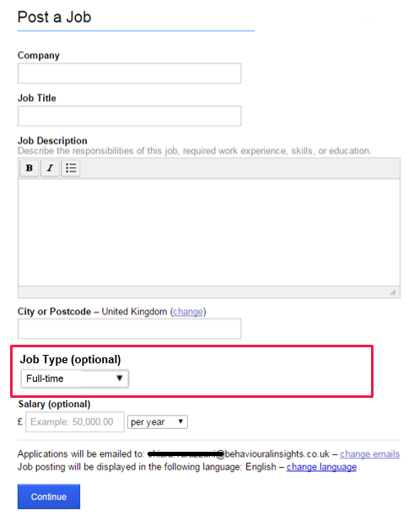
Figure 8. Example of template for the control group in trial 1A

The existing template may need to be slightly modified for our control group to get a meaningful outcome measure that can be compared across the trial arms. If, for example, we partnered with Indeed.co.uk, we would need to revise the drop-down menu for the ‘Job Type’ field in which the available choices could be, for example: ‘Full-time or part-time’, ‘Full-time’ or ‘Part-time’. This would allow us to compare the number of employers across the different templates who choose a flexible working option such as ‘Part-time’ or ‘Full-time or part-time’.
Treatment group 1: Adding flexible working as a default option. The aim is to test if selecting the default option that a job can be done flexibly increases the number of employers who mention flexible working in their job adverts. Employers would be required to actively change the job from being flexible to not being flexible. We expect that this would lead to a higher number of employers offering the job as flexible.
The specific options for flexible working (including dimensions such as the ability to work staggered or compressed hours) would be specified with the trial partner to ensure that they can be supported by the website. For illustrative purposes, below is a simple prototype from Indeed.co.uk where flexibility is indicated as the ability to do the job ‘Full-time or Part-time’.
Figure 9. Example of template for the treatment group in trial 1A
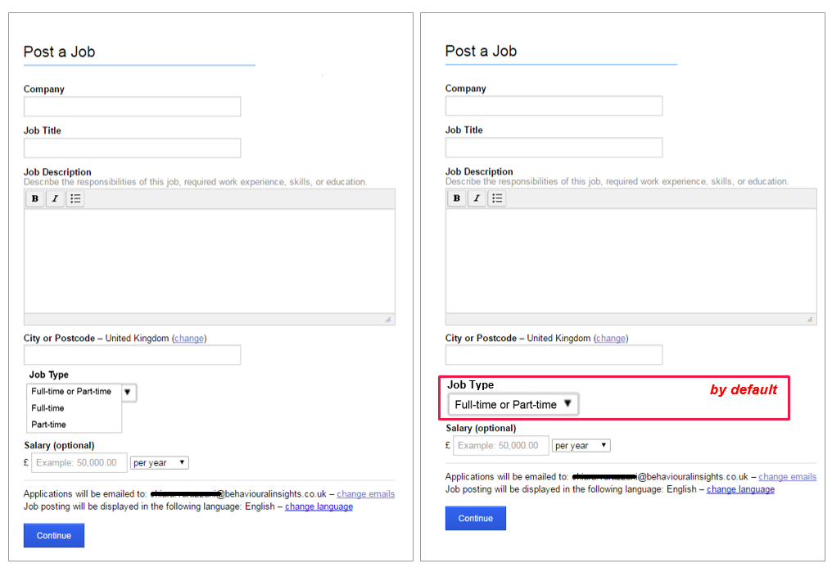
Treatment group 2: Flexible working as a default and salient option. Here we will test if including, for example, ‘Full-time or Part-time’ as the default option at the beginning of the template (before the job description) increases the number of employers mentioning flexible working in their job adverts.
Outcome measures for trial 1A
The primary outcome measure will be the proportion of job adverts posted on the website in which the employer explicitly mentions the degree of flexibility.

Outcome measure | Measurement
Number of job adverts mentioning the degree of flexibility | The final outcome measures would be specified together with the trial partner. Examples of simple outcome measures include:  - Number of job adverts in which the employer has chosen the option ‘Full-time or Part-time’ in the ‘Job type’ field (job can be done either full- or part-time)

Trial 1B: Influencing women
The aim of the second trial is to encourage more women of childbearing age to apply for jobs. This trial will examine how changing the amount of information about flexible working influences likelihood of applying for a job. The key question is:
Does mentioning the degree of flexibility in job adverts encourage applications from women of childbearing age?
Importantly, we are not testing whether offering the same job as flexible encourages more women to apply than if the job was not flexible. Instead, we suggest testing the effect of giving information about flexibility (for example, that a job cannot be done from home) in general.
This is based on evidence from behavioural science showing that women are more ambiguity averse than men. Ambiguity aversion describes a preference for known risks (decisions with risk) over unknown risks (decisions with ambiguity), meaning that women are less likely than men to prefer options which are ambiguous.
As women tend to be more ambiguity averse than men, the assumption is that they are potentially more interested in a job advert that makes explicit reference to the degree of flexibility. We expect that showing more information about flexible options decreases the overall ambiguity and thus increases the likelihood women will apply for a job.
Design for trial 1B
All employers arriving on the website to post an advert would be directed to a template with several mandatory fields regarding flexible working. The specific fields to be included would be co-designed together with the Commission and the trial partner. Below is a prototype example of what the new job advert template for Indeed.co.uk could look like if the flexible working questions included job type, flexible hours and ability to work from home. The red square is for illustration purposes only and will not be visible to the employer.

Figure 10. Example of testing whether flexibility of information encourages women to apply for jobs in trial 1B
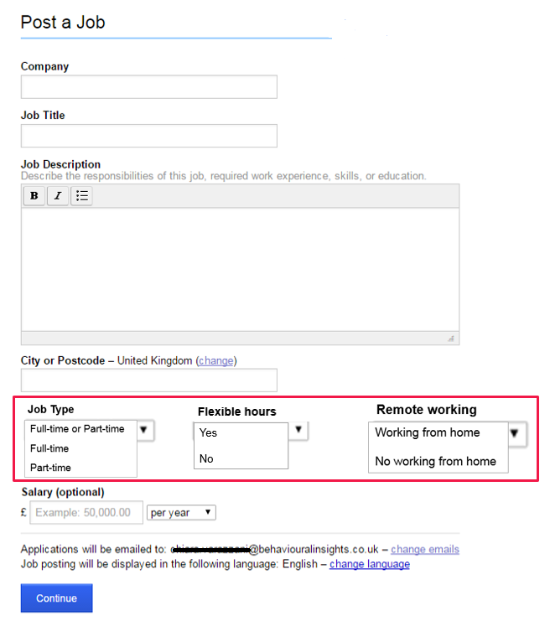
In this example, all employers are required to indicate flexibility regarding job type, hours and location. Randomisation is done at the level of individual job seekers so that not all job seekers will see the same amount of information. About half of the job seekers will see a control group advert with little information about flexibility, only information regarding job type. The other half will see a treatment group advert with more information about flexibility (job type, hours and location). Each time an applicant clicks to see a new advert, they will be randomly allocated to see either a control group or treatment group advert.
As the applicants apply for several jobs, the online job board will capture the number of applicants for the ‘little information’ version of each advert as well as the ‘more information’ version. The design of the RCT allows us to conclude that any difference in the proportion of applicants across the treatment and control groups can be attributed to the new job advert template. Furthermore, information about gender and age will allow testing whether the intervention is more effective for women than for men, and whether it is particularly effective for women of childbearing age.
Figure 11. Illustration of design for trial 1B
Control group: Little flexibility information. Job seekers will see a standard job advert with no explicit information regarding the degree of flexibility, only information about the ‘Job Type’, which could be: ‘Full-time or part-time’, ‘Full-time’ or ‘Part-time’.
Treatment group: Additional flexibility information. Job seekers will see an alternative version of the job advert giving explicit information about the degree of flexibility. The figure below shows the two versions of the job advert a job seeker might see when they navigate the job website.
Figure 12. Example of control and treatment group adverts in trial 1B

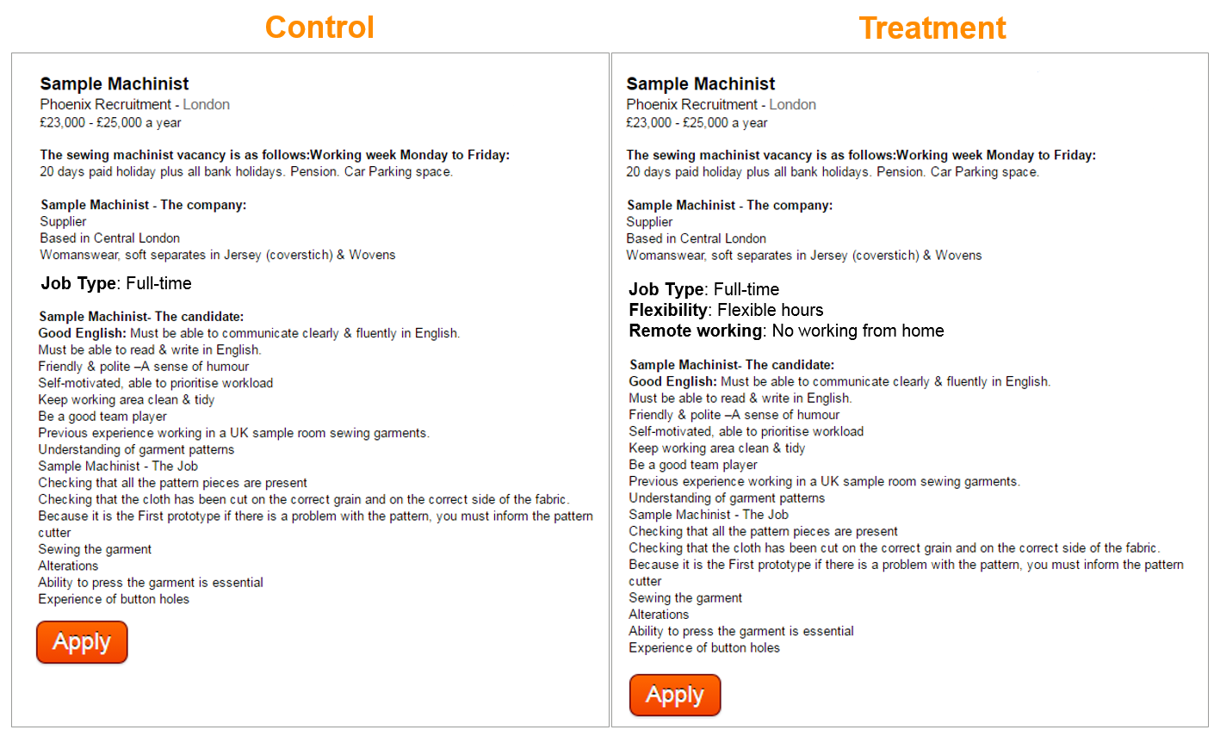
Outcome measures for trial 1B
The main outcome measures will be the number of applicants and, in particular, the number of women of childbearing age applying for jobs.
Outcome measure | Measurement
Percentage of women of childbearing age applying for jobs | - Whether a job seeker starts an application  - Whether a job seeker finishes an application  - Gender of the applicants  - Age of the applicants

Data collection for trials 1A and 1B
We will use the data about gender and age of applicants routinely collected by the online job board. Online job boards usually assign a unique identifying number to each job seeker (for example, a ‘member number’ on LinkedIn) that will allow matching applicants to the kind of advert that they have viewed (that is, a business-as-usual advert or an advert mentioning flexible working). To assess the effect of the intervention in more detail, other relevant information such as the sector and the size of the employers could be used in the analysis.

Emailing employers
We propose directly emailing employers to encourage them to undertake specific actions. Variants of the same email would allow testing what kind of messaging is most likely to change employers’ behaviour.
The aim of the following trials is to test how emails to employers can be used to:
1. Get more employers to offer flexible working
2. Get more employers to proactively discuss health and safety with pregnant women in their organisations
3. Get more employers to use the best practices for an unbiased recruitment.
Partners
There are several options for creating the mailing list to target employers. For example, we could use existing mailing lists, such as:
- HMRC mailing lists: most employers register for an email alert service so that HMRC can remind them when the latest employer information is available on the GOV.UK website. Normally HMRC send employers six email alerts a year, in February, April, June, August, October and December. Given that employers are more likely to read an email which is relevant to them, it would be better to use the emails that HMRC send around February or April, as decisions around resources are more likely to be taken at the end or start of the financial year.
- HSE: The Health and Safety Executive (HSE) also has a mailing list that employers and individuals can subscribe to. Optional fields in the registration process include location, size of organisation, status (for example, employee, employer, manager), occupation and industry sector. This information could be used to target the emails.
- CIPD: The Chartered Institute of Personnel and Development (CIPD) is a professional association for HR management professionals. Partnering with CIPD could allow targeting HR professionals.
Alternatively, to focus on key sectors or particular employers, we could use:
- A web scraping approach to create our own mailing list. Web scraping is a method to gather publicly available data by having a computer read websites. After gathering relevant contacts from websites, we can create our own mailing list to directly contact employers. This approach would offer considerable advantages as we could target specific employers (for example, employers who are currently recruiting), SMEs, or specific stakeholders (for example, HR managers or line managers).
Design trials for 2A, 2B and 2C
The employers on the mailing list will be randomly allocated to different groups. Each group will receive a different version of the email. Employers in the control group will receive a basic ‘business-as-usual’ email that gives factual information about the target behaviour but doesn’t use any messaging based on behavioural science. Employers in the treatment groups will receive variants of the email based on a different behavioural message (described in more detail in the ‘Solution’ section). The design of the RCT allows us to conclude that any difference in outcomes across the treatment and control groups can be attributed to the content of the email.

Figure 13. Illustration of design for email trials

Trial 2A: Influencing employer behaviour regarding flexible working
The first email trial seeks to answer the question:
‘Does emailing employers about flexible working get them to mention the degree of flexibility in job adverts?’
An example of an email using a loss aversion message is shown below:

Dear {First Name},

Did you know that more than 14 million of UK workers want flexible work?

You should simply ask yourself, ‘To avoid losing my best candidate, will I consider flexible working for this role?’

If the answer is ‘yes’, then say so on your job adverts and click here to discover more!

Best,

{Sign-off}

Outcome measures trials for trial 2A
The main outcome measure is the proportion of employers who show interest in finding out more about flexible working by clicking on a link embedded in the email that takes them through to a webpage with more information. In addition, the aim is to measure the proportion of employers offering flexible options in job postings. This can be measured by using web scraping to gather data on job postings on online job boards that mention flexible working.
Outcome measures | Measurement
Number of employers who show interest in flexible working | - Number of clicks and, if possible, time spent on the website
Number of employers offering flexible working | - Keywords ranking of public available data that will be collected using web scraping

Trial 2B: Influencing employer behaviour regarding health and safety
The second email trial seeks to answer the question:
Does emailing employers about health and safety get employers to express interest and provide specific training to managers?
Outcome measures trials for trial 2B
The primary outcome measure will be the numbers of clicks to a website containing key information and training on pregnancy-related health and safety.
We will also measure the number of employers who provide training for managers on managing pregnancy and maternity health and safety issues. This will be measured by using data on who attended training after the emails were sent, and by sending a follow-up online survey to employers. Data on training can be gathered from organisations such as the Health and Safety Executive (HSE) or the Advisory, Conciliation and Arbitration Service (Acas).
Additionally, employers will be able to download a health and safety document (for example, a conversation guide or a form for conducting an overview of risks). The number of employers downloading this document can be used as an additional outcome measure.
Outcome measures | Measurement
Employers showing interest on pregnancy and maternity health and safety issues | - Number of clicks and, if possible, time spent on the website
Number of employers who provide training for managers on managing pregnancy and maternity health and safety issues – data from training provider | - Data from a training provider (such as HSE or Acas) on the number of employers who have signed up to or completed training
Number of employers who provide training for managers on managing pregnancy and maternity health and safety issues – self-reported | - Follow-up online survey asking employers if they have provided managers with training covering risks to pregnant women and new mothers
Number of employers using a health and safety document | - Number of downloads of the health and safety document from the website

Trial 2C: Influencing employer behaviour regarding recruitment
The third email trial seeks to answer the question:
‘Does emailing employers about best practice in recruitment increase the likelihood that the employers express interest and provide specific training to managers?’
Outcome measures trials for trial 2C
The primary outcome measure will be the number of clicks to a website containing key information on the best recruitment practices. Moreover, we will measure the number of employers who show an interest in improving their recruitment practices either by requesting an assessment of their current recruitment practices (provided in partnership; for example, with BEIS or CIPD) or by participating in training on good recruitment practices.
Outcome measures | Measurement
Number of employers who are interested in finding out more about unbiased recruitment | - Number of clicks to find out more about what the best practices to avoid biased recruitment are and, if possible, time spent on the website
Number of employers who request advice to improve recruitment practices | - Follow-up email survey to ask employers if they would be interested in receiving a ‘recruitment health check’ on how good their recruitment practices are. This would be designed to check the general degree of interest for a service that doesn’t yet exist. Alternatively, if it is possible to set up such a service (for example, with BEIS or CIPD), the follow-up email survey would ask interested employers to submit their contact information.  For example: ‘The Department for Business, Energy and Industrial Strategy (BEIS) can help you check if you are using the best recruitment practices. Would you like us to check your recruitment practices and find better candidates? If you are interested, please leave your phone number below and we will get back to you.’

Evaluating the effect of trials
All five trials described above have been designed to produce a robust evaluation of each intervention. Although the exact outcome measures will in part depend on the trial partner and possibilities for data capture, each trial will show the percentage of employers (or women) who changed their behaviour as a consequence of receiving the intervention. To conduct these trials, we will need to find trial partners and, therefore, the exact outcome measures may change. The evaluation will seek to provide information on:
- The percentage of employers who offer flexible working
- The percentage of women of childbearing age who apply for jobs
- The percentage of employers who proactively manage pregnancy-related health and safety issues and offer training to line managers
- The percentage of employers who take steps to improve their recruitment practices to reduce discrimination against women of childbearing age.
We will also provide an estimate of how many employers would change their behaviour nationally if the intervention was rolled out on a larger scale.

References

Behaghel, L., Crépon, B. and Le Barbanchon, T. (2011), ‘Do anonymous resumes make the battlefield more even? Evidence from a randomized field experiment’, Document, Crest (Paris) und J-PAL Europe. [accessed 10 October 2017]
BIS and EHRC [Department for Business, Innovation and Skills, and Equality and Human Rights Commission] (2015), ‘Pregnancy and maternity-related discrimination and disadvantage: summary of key findings.’ [accessed: 7 October 2017].
BIT [Behavioural Insights Team, Cabinet Office] (2013), Applying behavioural insights to charitable giving [Online]. [accessed: 7 October 2017].
Bock, L. (2015), Work rules!: Insights from inside Google that will transform how you live and lead. London: John Murray.
Bohnet, I. (2016), What works: Gender equality by design. Cambridge, Massachusetts: Harvard University Press.
Bohnet, I., Bazerman, M.H. and van Geen, A. (2012), ‘When performance trumps gender bias: joint versus separate evaluation’, HKS Faculty Research Working Paper Series 12-084. John F. Kennedy School of Government, Harvard University.
Borghans, L., Golsteyn, B., Heckman, J. and Meijers, H. (2009), ‘Gender differences in risk aversion and ambiguity aversion’, Journal of the European Economic Association, 7(2–3), pp. 649–58.
Bragger, J.D., Kutcher, E., Morgan, J. and Firth, P. (2002), ‘The effects of the structured interview on reducing biases against pregnant job applicants’, Sex Roles, 46(7–8), pp. 215–26.
Dolan, P., Hallsworth, M., Halpern, D., King, D. and Vlaev, I. (2010), Mindspace: influencing behaviour through public policy [Online]. Institute for Government and Cabinet Office. [accessed 7 October 2017].
EHRC [Equality and Human Rights Commission] (2016a), Pregnancy and maternity-related discrimination and disadvantage: experiences of employers. [accessed 5 October 2017].
EHRC [Equality and Human Rights Commission] (2016b), Pregnancy and maternity-related discrimination and disadvantage: experiences of mothers. [accessed 5 October 2017].
Fox, C.R. and Tversky, A. (1995) ‘Ambiguity aversion and comparative ignorance’, The Quarterly Journal of Economics, 110(3), pp. 585–603.
Gaucher, D., Friesen, J. and Kay, A.C. (2011), ‘Evidence that gendered wording in job advertisements exists and sustains gender inequality’, Journal of Personality and Social Psychology, 101(1), p. 109.
Gee, L.K. (2015), ‘The more you know: information effects in job application rates by gender in a large field experiment’, SSRN Electronic Journal. Available at: 10.2139/ssrn.2612979.
Gov.uk (2013), Automatic enrolment opt out rates: findings from research with large employers [Online]. [accessed: 7 October 2017].
Hallsworth, M., Chadborn, T., Sallis, A., Sanders, M., Berry, D., Greaves, F., Clements, L. and Davies, S.C. (2016), ‘Provision of social norm feedback to high prescribers of antibiotics in general practice: a pragmatic national randomised controlled trial’, The Lancet, 387(10029), pp. 1743–52.
Kahneman, D., Knetsch, J.L. and Thaler, R.H. (1991), ‘Anomalies: the endowment effect, loss aversion, and status quo bias’, The Journal of Economic Perspectives, 5(1), pp. 193–206.
Kahneman, D. and Tversky, A. (1979), ‘Prospect theory: an analysis of decision under risk’, Econometrica: Journal of the Econometric Society, 47(2), pp. 263–91.
Macan, T. (2009), ‘The employment interview: a review of current studies and directions for future research’, Human Resource Management Review, 19(3), pp. 203–18.
Morgan, W.B., Walker, S.S., Hebl, M.M.R. and King, E.B. (2013), ‘A field experiment: reducing interpersonal discrimination toward pregnant job applicants’, Journal of Applied Psychology, 98(5), p. 799.
Moss-Racusin, C.A., Dovidio, J.F., Brescoll, V.L., Graham, M.J. and Handelsman, J. (2012), ‘Science faculty’s subtle gender biases favor male students’, Proceedings of the National Academy of Sciences, 109(41), pp. 16474–9.
Mullainathan, S. and Shafir, E. (2013), Scarcity: why having too little means so much. London: Allen Lane.
Terrell, J., Kofink, A., Middleton, J., Rainear, C., Murphy-Hill, E., Parnin, C, and Stallings, C. (2016). ‘Gender differences and bias in open source: pull request acceptance of women versus men’, PeerJ Preprints 4:e1733v2. Available at: https://doi.org/10.7287/peerj.preprints.1733v2 [accessed: 7 October 2017].
Timewise (2013), Press release: The flexibility trap [Online]. [accessed: 7 October 2017].
Timewise (2014), A flexible future for Britain? [Online]. [accessed: 7 October 2017].
Timewise (2016), The Timewise Flexible Jobs Index 2016 [Online]. [accessed: 7 October 2017].

Appendix 1: Long list of target behaviours
- Employers to conduct recruitment (job posting, interviews, etc.) in a way that does not discriminate against pregnant women, women with children and women of childbearing age
- Mothers and pregnant women to apply for jobs without feeling guilty
- Women to know their rights and assert them
- Women to raise problems around harassment or discrimination early
- Employers to make complaints processes easy and normalised
- Employers to take action against those who bully women
- Women to ask for flexible working in a timely manner
- Women to feel like they do not need to apologise for flexible working
- Employers to get in touch with women with a reasonable frequency and at the right time during maternity leave
- Employers to agree communication during maternity leave before maternity leave begins
- Employers to have early and ongoing conversations about health and safety risks, and act upon them
- Senior leaders to visibly champion pregnancy and flexible working
- Employers to react positively when told about pregnancy
- Employers to make sure women can take time to attend antenatal appointments
- Employers to proactively manage resentment of colleagues
- Employers to actively use keeping in touch (KIT) days
- Employers and colleagues to keep mothers updated while on maternity leave
- Employers to keep promotions and progression (and career needs in general) on the agenda
- Women to increase expectations and to demand support
- Employers to provide facilities and breaks to express milk

Contacts
This publication and related equality and human rights resources are available from the Commission’s website.
For advice, information or guidance on equality, discrimination or human rights issues, please contact the Equality Advisory and Support Service, a free and independent service.

Telephone 0808 800 0082
Textphone 0808 800 0084
Hours 09:00 to 19:00 (Monday to Friday)
10:00 to 14:00 (Saturday)
Post FREEPOST Equality Advisory Support Service FPN6521
Questions and comments regarding this publication may be addressed to: correspondence@equalityhumanrights.com. The Commission welcomes your feedback.

Alternative formats
This publication is also available as a PDF file from the Commission’s website. For information on accessing a Commission publication in an alternative format, please contact: correspondence@equalityhumanrights.com.
© 2017 Equality and Human Rights Commission
Published November 2017

Of managers, 69% believed flexible workers were less ambitious that their full-time colleagues (Timewise, 2014).
You can take the Implicit Association Test (IAT) to find out about your own unconscious biases, available at: https://implicit.harvard.edu/implicit/. People who make more gender stereotypic associations on this test have been found to laugh more at sexist jokes, and the scores in this test also predicted discrimination in simulated hiring situations (preferring white applicants).
Figure from Bohnet et al., 2012.
The Stroop test is a commonly used measure of cognitive functioning. It consists of measuring reaction times when people are asked to name colours (‘red’, ‘blue’) that are written in different colours (for example, reaction time is shorter when naming the word ‘blue’ written in blue than when naming the word ‘blue’ written in red).
According to a report by the Family Friendly Working Hours Task Force, 58% of small to medium-sized enterprises reported improvement in productivity, and 70% of employers noted some or significant improvement in employee relations.

