Personalisation

A report about how some groups are missing out on personalisation


Personalisation means that you decide who supports you to do the things you like as well as with everyday things like getting washed and dressed.

About us

We are called the Equality and Human Rights Commission.



We work to make sure everyone gets treated
in a good and fair way.



We also work to make sure people get their
human rights.

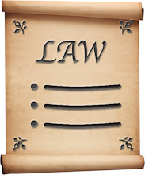
Human rights are rights that the law says everyone should have.
For example, everyone has the right to

- get an education
- believe in things that are important to them.

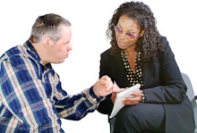
We give people information and advice.

And we make sure people follow the laws about treating people in a good and fair way.

Personalisation

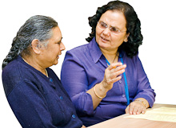
Personalisation is the name for a way of choosing and paying for the services and support that you want.



Personalisation is about making a plan about the support you want.


You use the money that you have to choose and pay for the services and support that are right for you.


Your money can be from
- direct payments
- personal budgets
- your savings.

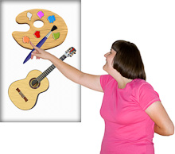
It means that you decide what activities you want to do.
You decide who supports you to do the things you like as well as with everyday things like getting washed and dressed.

What we think about personalisation
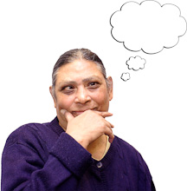

We think that having a choice about your care and support is important.

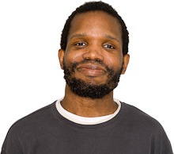
We think personalisation helps you to

- be more independent
- make the most of your skills and abilities
- be in control of your life.

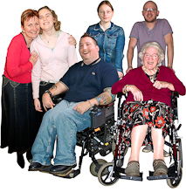
We think everyone who needs extra care and support should have the chance to get the support they need through personalisation.

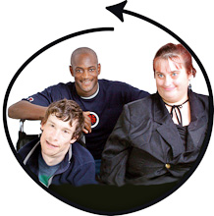

We think personalisation should work for everyone.



But, when we looked at how personalisation is working we found that some people are at risk of missing out.

What we found out

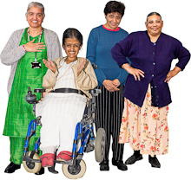
When we looked at how personalisation is working we found that some groups of people living in England are missing out.

We worked with 4 groups of people to find out why people are missing out.

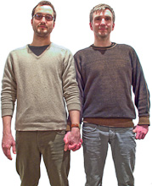
These groups were

- lesbian, gay, bisexual and transgender people in the north west


- young people who use mental health services in the north east


- disabled gypsies and travellers in the east midlands

- older people in the south west.


We looked at
- what stops people using personalisation
- what helps people use personalisation.
What people told us
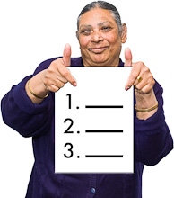

Here are some of the main things people told us about the problems with personalisation.


Young men in the north east
Information about personalisation was not right for them.
There was no information for young men.

Older people in the south west

Information about personalisation was hard to understand.
A lot if it was on the internet. Many people did not have a computer or found information on the internet was no use to them.
People wanted personalisation explained to them face to face.

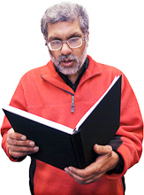
Young men, gypsy and traveller groups
Some people in these groups had problems with reading.
This made it very hard to understand the written information about personalisation.

Lesbian, gay, bisexual and transgender people in the north west
People told us the pictures used in the information about personalisation did not include them.
They felt that the information did not include them.

What makes it hard for people to use personalisation

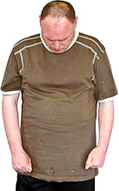
Some groups of people we spoke to found it more difficult to get any sort of service to help them.

This made it even more difficult to get a service that was right for them.

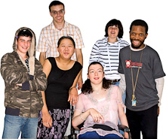
These groups of people are
- young men at risk of suicide
- gypsies
- travellers.

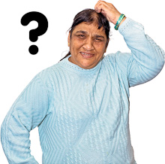

Many people did not know about personalisation.
They did not know how it works or that it was something they could use.

Some of the other things people told us about that made it hard for them to use personalisation
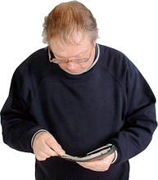

- no groups in their area to help them manage the money or organise support


- staff who had the job of telling people about personalisation often seemed to find it hard to understand personalisation themselves


- people found it hard to trust that they would be treated in a good way.
This meant they did not use services or tell staff about their needs.

Advocacy


We wanted to find out if people got the chance to have an advocate to help them with personalisation.

An advocate is someone who can help you speak up or speak up for you.

We talked to over 400 advocacy services in England.

What we found out about advocacy
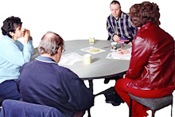

- Advocacy services often don’t know about some groups of people like gypsies and travellers in their area.

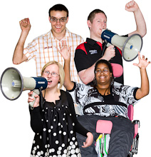
- Some services are set up to help groups of people who are more at risk of missing out.

- Some groups will help anyone who needs support to speak up.

Not all advocacy groups monitored the sorts of people they were helping.
For example, some groups did not check to see if they were helping people of different faiths or people who are lesbian and gay.

They had no way of knowing if they were helping people who are more at risk of missing out on personalisation.

More about what we found out about advocacy

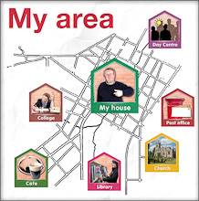

It seems that were you live has a big effect on what advocacy support you get and how good it is.

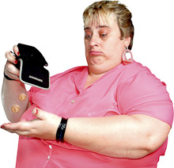

This means some people are missing out on the chance to get a personal budget or direct payment.

We think that many people will be able to use personalisation if they have
- good information
- help to find the right services
- good advice to help them manage their direct payment or personal budget.

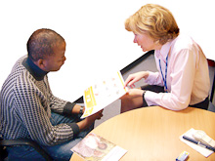
Advocacy services need to
- understand how to help people who are at risk of missing out
- keep a check that they are helping people who are at risk of missing out.

What we will do
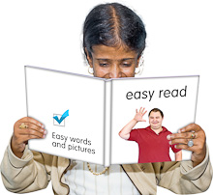

We want people to have good information that is right for them.



We want people to have advocacy and help to make the most of personalisation.

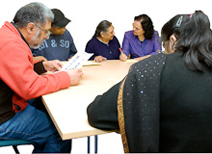
In the work we do with other groups on care and support we will make sure that they know how important advocacy is.

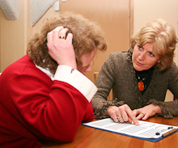
When we look into the human rights of older people who get care in their own homes we will also check to see if personalisation is working for them.

